Node Design Document

Overview
The Node Design Document describes the system and subsystem architecture, input formats, output layouts and detailed design of human-machine interfaces.

Each “Node” in an iVMS system consists of an ESP8266 (on a nodeMCU dev kit) along with the following sensors:
- MAX30102 SPO2 and heart rate sensor
- CK101 Blood pressure measurement system + Breakout board
- ECG measurement system
- Alarm Buzzer and Light
- User button

Upon acquisition of data from these sensors, each node publishes an MQTT message for each ‘topics’ (read sensor datas).

SYSTEM ARCHITECTURE
Following flowchart shows the device behavior on reset.
Start DP timer
Reset

DP stage complete?
DP stage timeout?
Device Provisioning Stage (Enter SSID, password, hospital name, bed num, MQTT Broker address etc.)
No No

Yes Yes
Operation Mode 1
Start PO timer

PO stage complete?
PO stage timeout?
Patient Onboarding Stage: Enter Patient ID, Name, age, gender, biometric thresholds (maxBP, maxHeartRate etc.)
No No

Yes
Yes
Operation Mode 2
Operation Mode 3

Device Provisioning Stage
A ‘factory reset’ device starts an open Access Point (softAP) with SSID set to the ESP8266’s MAC address. The same address is displayed on the local LCD to identify a node in a room containing multiple nodes. Any wi-fi capable device (mobile phones, laptops, tablets etc.) can scan for nearby wi-fi stations and find the node.
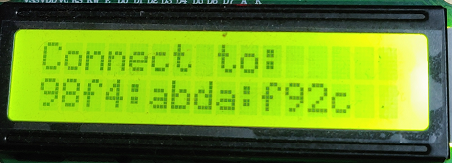
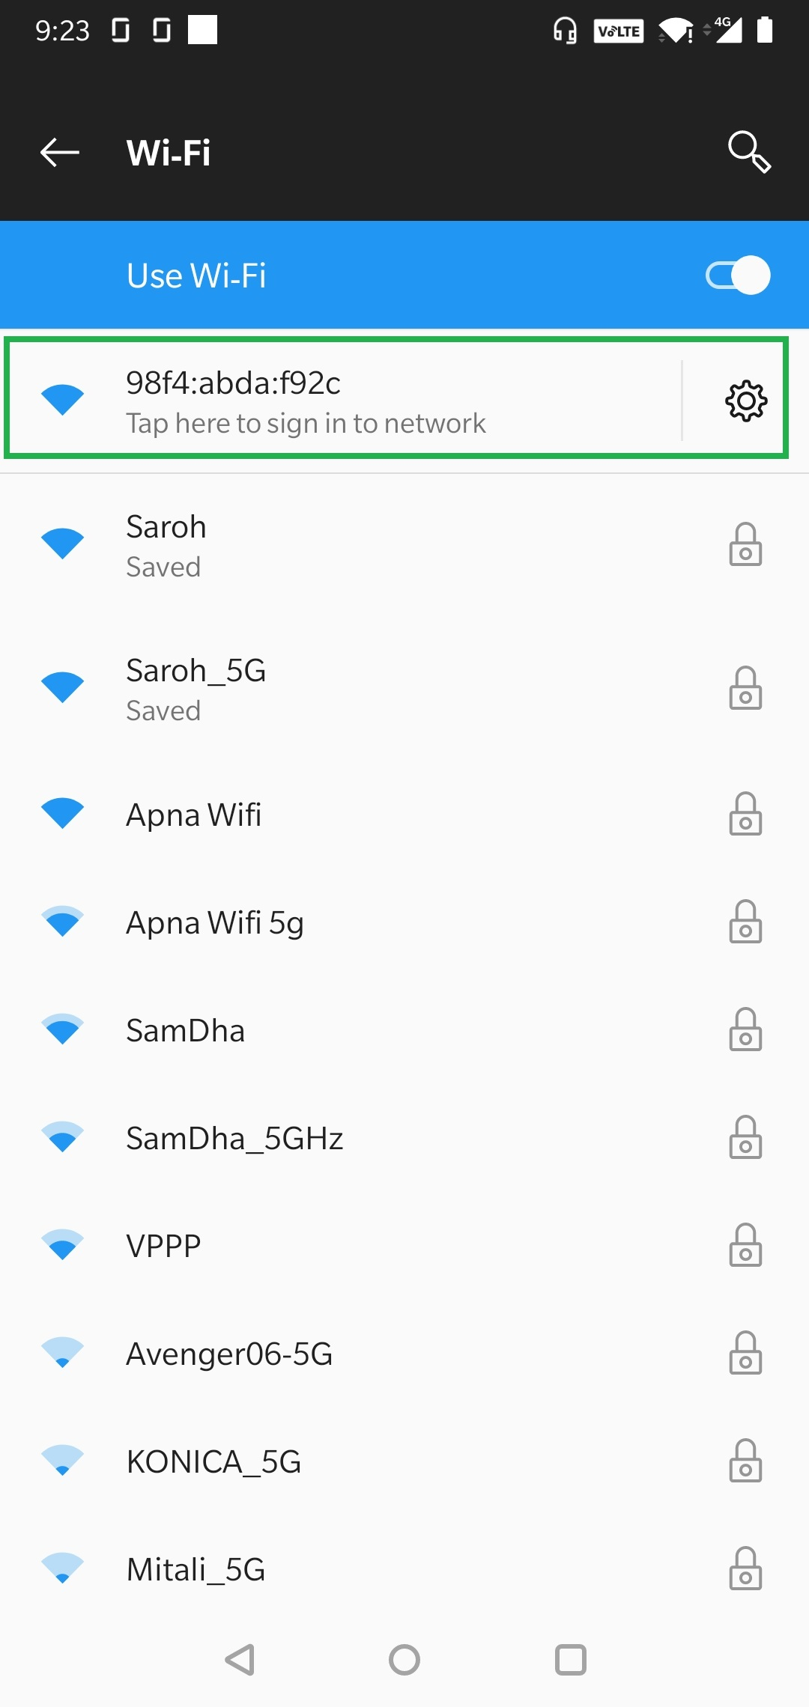
Next, the user must connect to the node’s SSID and click on the ‘tap to sign into network’ pop up. This brings on the ‘Device Provision Page’ on the user’s screen. The user enters all the details and presses the save button. The device now tries to connect to the provided SSID. If it is connected, the provisioning is complete, and the device moves on to Patient Onboarding Stage (PO). Else, the softAP is restarted and the user is prompted to connect via the local LCD (as before). To put the device into factory reset mode, press the user button for 10 seconds.

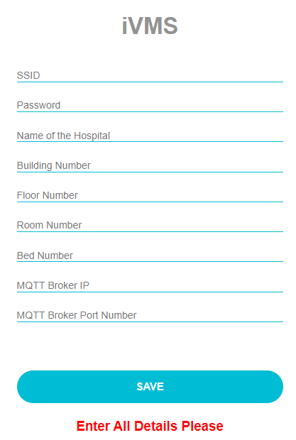

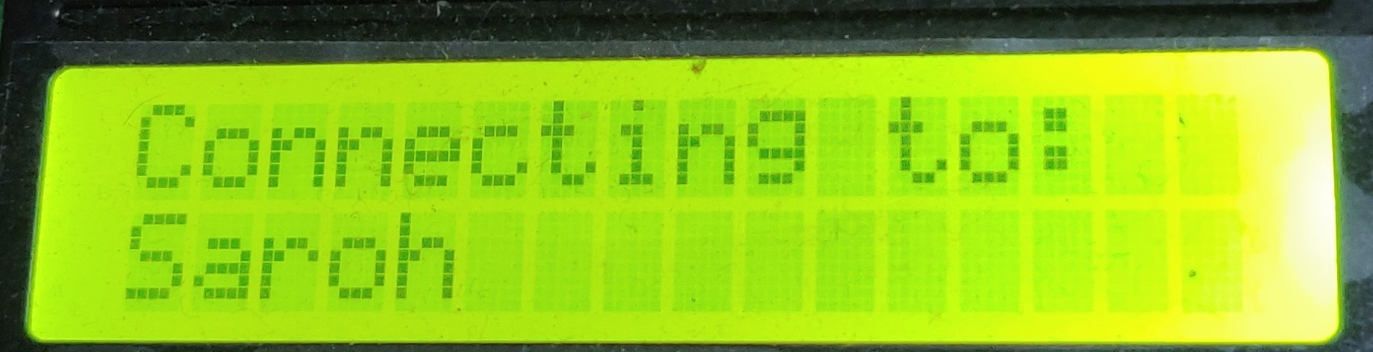

Operation Mode 1 (Local Mode)
The node stays in this mode till a device reset (via reset button or due to power switch off/on).
Sensors Data Acquisition:
- 10 seconds for spO2, heart rate
- 60 seconds for BP
- X seconds for ECG
Display all parameters on local 16x2 LCD.
Use default thresholds to determine if alarm is required to be triggered:
Eg.:
- Default HR = 60 – 140
- Default spO2 > 92%
- BP sys < 90, BP dia < 140

Patient Onboarding Stage
Details specific to a patient (ID, name, gender, BP thresholds, Heart Rate thresholds etc.) are required to be entered in the node for every patient. This is done as part of the ‘Patient Onboarding Stage’.
Once the node connects to the local router (ie, after the DP stage), it obtains a unique IP address. This address is displayed on the 16x2 LCD and the user is prompted to enter the details for ‘Patient Onboarding’. The user enters this IP address in a web browser in a device connected to the local router. This brings up the Patient onboarding page shown below. User enters all data and presses submit to complete the PO stage.
To erase previous patient data, press the user button and while it is pressed, reset the device (either through reset button or via power off/on). Once the LCD mentions “erasing previous data”, release the user button.

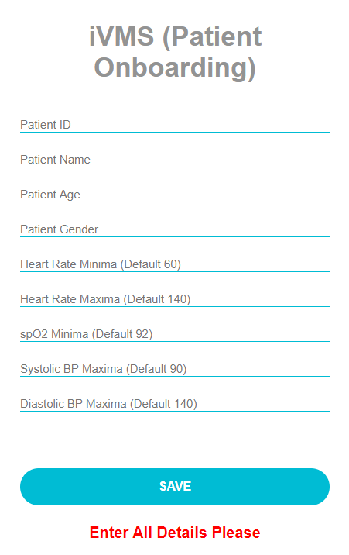

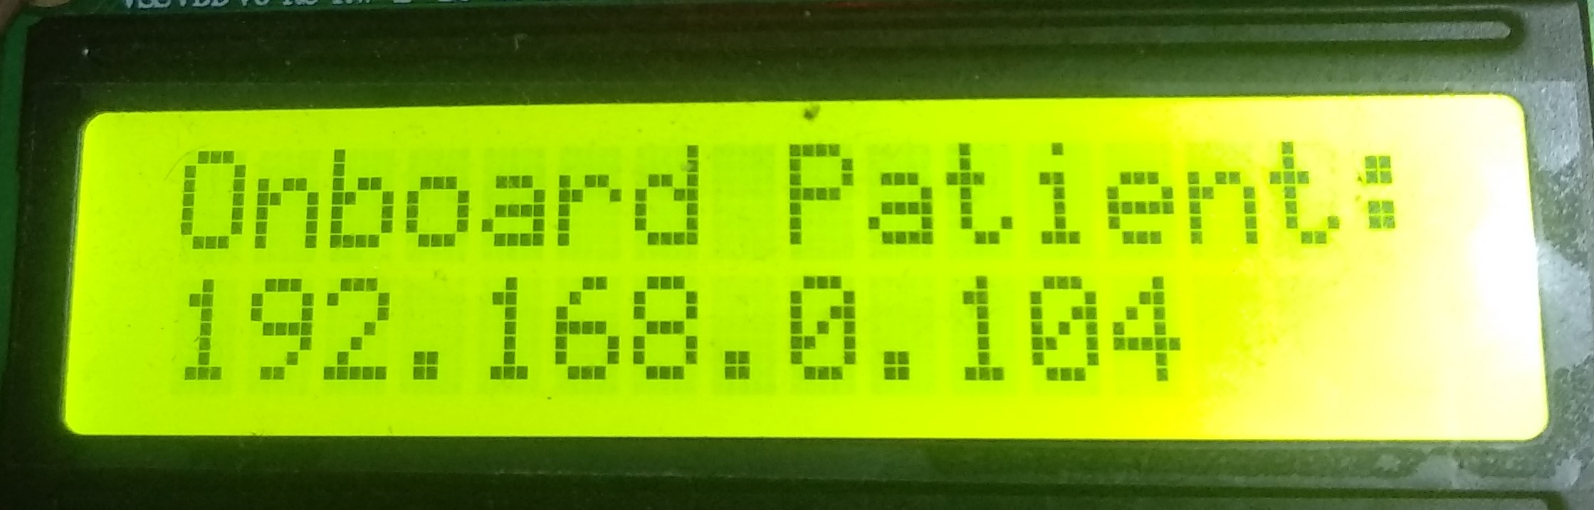

Operational Mode 2
The node stays in this mode till a device reset is performed.
Sensors Data Acquisition:
- 10 seconds for spO2, heart rate
- 60 seconds for BP
- X seconds for ECG
Display all parameters on local 16x2 LCD.
Use default thresholds to determine if alarm is required to be triggered:
Eg.:
- Default HR = 60 – 140
- Default spO2 > 92%
- BP sys < 90, BP dia < 140

Publish sensor data to MQTT broker as MQTT topics. The topic format is as follows:
WardNO\BedNO\HR\
..\spO2\
..\diaBP\
..\sysBP\\
..\patientDetails\ -> “Unknown”

Alarm Beeps and LCD informs that patient onboarding is pending every 2 minutes.
“patientDetails” shows patient as “UNKNOWN”

Operational Mode 3
The node stays in this mode till a device reset is performed.
Sensors Data Acquisition:
- 10 seconds for spO2, heart rate
- 60 seconds for BP
- X seconds for ECG
Display all parameters on local 16x2 LCD.
Use preset thresholds to determine if alarm is required to be triggered.
Publish sensor data to MQTT broker as MQTT topics. The topic format is as follows:
WardNo\BedNo\HR

..\spO2\
..\diaBP\
..\sysBP\

PUBLISHED MQTT Topic data format
This is a list of topics which each node will publish to the MQTT broker:

Vital Name | MQTT topic | Value type
IP address | WardNum\
Heart Rate | WardNum\BedNum\HR\ | UINT8
spO2 | WardNum\BedNum\spO2\ | UINT8
Diastolic BP | WardNum\BedNum\diaBP\ | UINT8
Systolic BP | WardNum\BedNum\sysBP\ | UINT8
PPG waveform | WardNum\BedNum\ppg\ | Comma separated UINT32 array (length 100)
ECG waveform | WardNum\BedNum \ecg\ | Comma separated UINT32 array (length 100)
Patient Details | WardNum\BedNum\patientDetails | CSV:
  Position | Detail Name | Value type
  0 | Patient ID | String
  1 | Patient Name | String
  2 | Patient Age | UINT8
  3 | Patient Gender | String (eg: M/F/O)
  4 | diaBP Threshold | UINT8
  5 | sysBP threshold | UINT8
  6 | Sp02 thresh | UINT8
  7 | HR thresh min | UINT8
  8 | HR thresh max | UINT8
  9 | IP address | String (eg: 192.168.0.100)

Subscribed MQTT topics
This is a list of topics subscribed to by each node. These topics must be published by the broker:
Topic Name | MQTT topic | Value type | Description
sendDetails | WardNum\BedNum\ sendDetails \ | BOOL | If the broker sets this to true, node publishes the “patientDetails” topic.

